**EBS (ELASTIC BLOCK STORE)**

Amazon Elastic Block Store (Amazon EBS) provides scalable, high-performance block storage resources that can be used with Amazon Elastic Compute Cloud (Amazon EC2) instances.

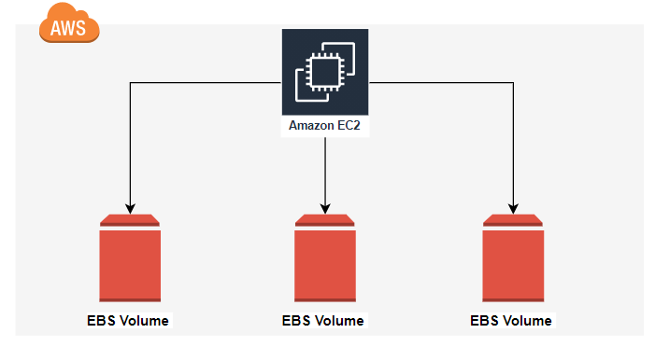

* **Create EBS and attach EBS to 3 different Instances**
* Open AWS account and Create an Instance with the name of EBS.

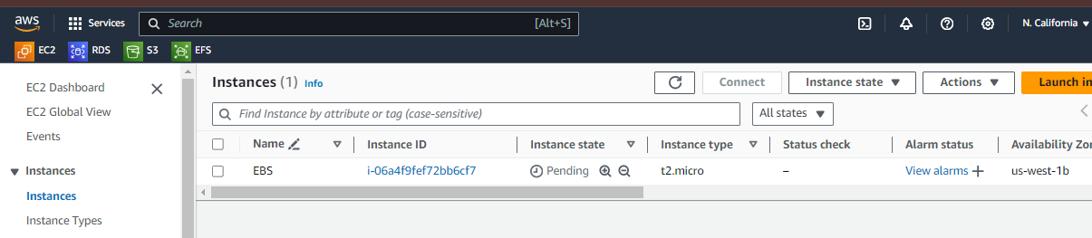

* After Instance creation connect to the instance EBS.

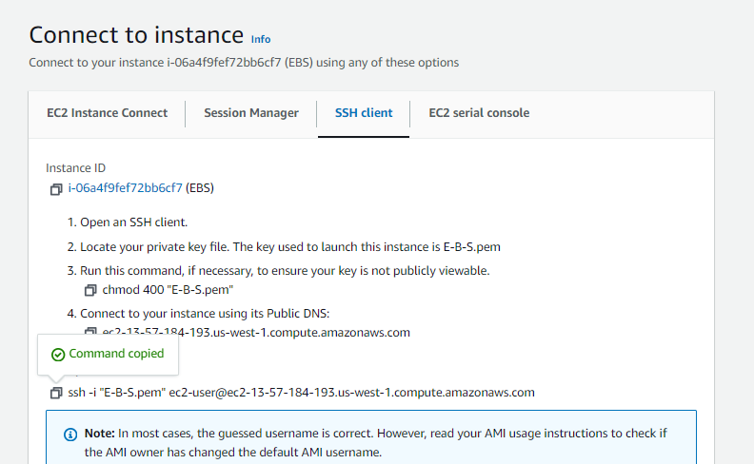

* After the connection with server logon to root user with the command sudo -i.
* And type the command df -h for the disk storage details in human readble language.

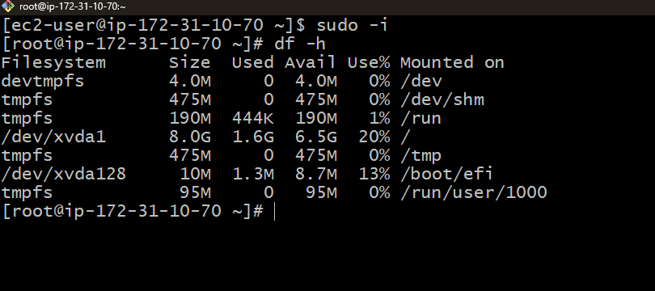

* After that create an volume with details Volume type is General purpose SSD(gp3).
* Size of the volume to be added is 10 GIB With 3000 IOPS.
* I have created the volume in the availability zone of us-west-1b.
* After the creation of volume click on the actions.
* And attach the volume to existing instance.

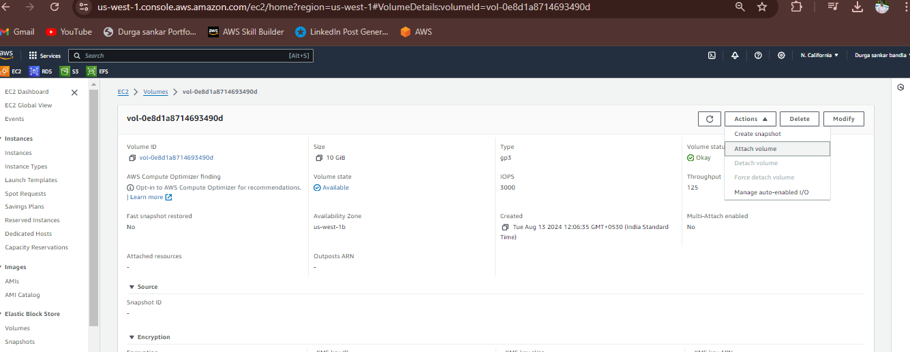

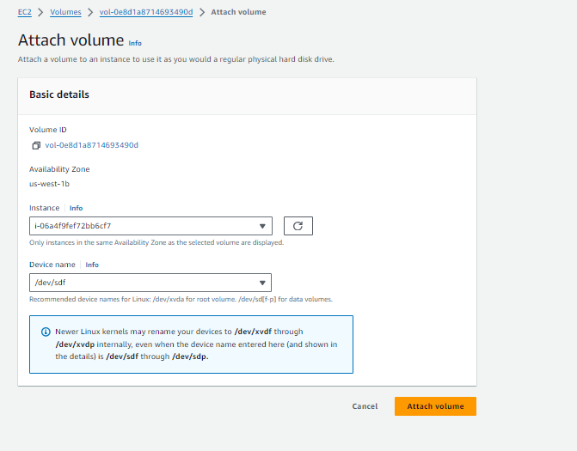

* We attached the volume to instance with the device name /dev/sdf.
* And then click on attach volume.
* Now for EC2 instance total storage will be 18GiB(8 GiB default storage+10 GiB attached volume).
* Attached volume will be available in block storage, for checking that storage in git bash use lsblk command.
* For checking is there any file system in device ->file -s /dev/xvdf
* For creating file system ->mkfs -t xfs /dev/xvdf
* Creating a nested directory->mkdir -p apps/volume
* For mounting the storage block storage to the root storage, we need to use Mount /dev/xvdf apps/volume.
* After mounting the storage total output storage for the root user is 18 GiB as shown in below.

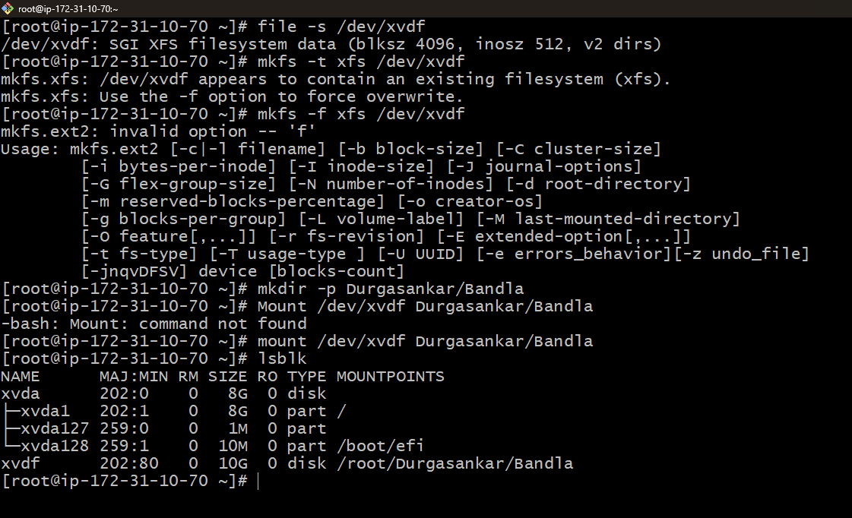

**Conclusion :**

But our aim is to connect the EBS to 3 different instances Once created the instance try to attach the instance to the EBS volume but we can not able to attach the EBS it will be disables because the EBS volume attached with instance 1. At a time, we can not able to attach multiple EC2 instances to the same EBS volume. But we detach the EBS volume from the instance 1 and able to attach to the instance 2.

**B. DURGASANKAR**

[**durgasankarbandla99@gmail.com**](mailto:durgasankarbandla99@gmail.com)